BTech Degree Examination May 2015

Qn1. Write a note on UNIX versions and standards?
History of UNIX is divided into two periods:
Early years
Root of the UNIX is found in early multiuser OS of 1960.In 1965, AT &T and MIT joined in a project to develop Multics.
In 1969, Ken Thompson create uniplexed information and computing system on PDP-7 1971. Dennis Ritchie joined together and named it UNIX and moved to PDP 11/20 written in assembly language.
V1 -> original version.
V3 -> first version with program written in C .
V4 -> completely written in C, now portable in hardware platform.
V5 -> first version released to used in universities.
V7 -> introduce Bourne shell
Modern Era
In 1979, UNIX splitted in two camps:
- AT & T UNIX
- BSD UNIX
AT & T create commericial version of UNIX:
- System lll (1982)
- System V (1984) – base of nowadays UNIX systems.
BSD create:
  - DEC VAX System
  - BSD 4.1 (1981)
  - BSD 4.2 (1983)
  - BSD 4.4 (1983)
Qn 2. How will you compare two files in UNIX?
grep -f file1 file2
-f FILE, --file=FILE
Obtain patterns from FILE, one per line. The empty file contains zero patterns, and therefore matches nothing.
Qn 3. What is daemon process? Give examples.
A daemon is a long-running background process that answers requests for services.
A daemon is a type of program on Unix-like operating systems that runs unobtrusively in the background, rather than under the direct control of a user, waiting to be activated by the occurance of a specific event or condition.
Daemons are usually instantiated as processes.
Daemons are recognized by the system as any processes whose parent process has a PID of one, which always represents the process init. init is always the first process that is started when a Linux computer is booted up (i.e., started), and it remains on the system until the computer is turned off. init adopts any process whose parent process dies (i.e., terminates) without waiting for the child process's status. Thus, the common method for launching a daemon involves forking (i.e., dividing) once or twice, and making the parent (and grandparent) processes die while the child (or grandchild) process begins performing its normal function.
Examples of daemons that it starts include crond (which runs scheduled tasks), ftpd (file transfer), lpd (laser printing), rlogind (remote login), rshd (remote command execution) and telnetd (telnet).
Some daemons are launched via System V init scripts, which are scripts (i.e., short programs) that are run automatically when the system is booting up. They may either survive for the duration of the session or be regenerated at intervals.
Qn 4. Write a shell script that will add two numbers which are supplied as command line arguments
#!/bin/bash
num1=$1
num2=$2
sum=`expr $num1 + $num2`
echo “The sum is”
echo $sum

Save the program as calc.sh
Compile it as $sh calc.sh 5 9

Qn 5. Explain the use of exec command.
When referring to a command line such as Linux or Unix, exec is a BOURNE and POSIX shell command that replaces the current shell process with the command specified after exec. This command does not create a new PID. For example, if you were to run exec <command>, the shell would be replaced by that command. When that command is exited, the shell will exit.
- A process may replace its current code, data and stack with those of another executable file by using one of the exec () family of system calls.
- When a process executes an exec (), its PID and PPID numbers stay the same – only the code that the process is executing changes.
exec replaces the current program in the current process, without forking a new process.
e.g:
exec bash : Makes you login shell bash

Qn 6. Explain the architecture of UNIX.

Unix Architecture
Here is a basic block diagram of a Unix system –

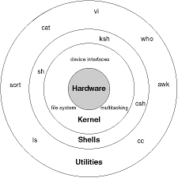

The main concept that unites all the versions of Unix is the following four basics −
- Kernel − The kernel is the heart of the operating system. It interacts with the hardware and most of the tasks like memory management, task scheduling and file management.
- Shell − The shell is the utility that processes your requests. When you type in a command at your terminal, the shell interprets the command and calls the program that you want. The shell uses standard syntax for all commands. C Shell, Bourne Shell and Korn Shell are the most famous shells which are available with most of the Unix variants.
- Commands and Utilities − There are various commands and utilities which you can make use of in your day to day activities. cp, mv, cat and grep, etc. are few examples of commands and utilities. There are over 250 standard commands plus numerous others provided through 3rdparty software. All the commands come along with various options.
- Files and Directories − All the data of Unix is organized into files. All files are then organized into directories. These directories are further organized into a tree-like structure called the filesystem.
Qn 7. Explain various environment variables in UNIX?
Environmental variables: -Store values about the user’s working environment.
The various environment variables are:
CDPATH: Contains the search path for cd command when the directory argument is a relative pathname.
COLUMNS: Defines the width, in characters, of your terminal. The default is 80.
EDITOR: Pathname of the command-line editor.
ENV: Pathname of the environment file.
HISTFILE: Pathname for the history file.
HISTSIZE: Maximum number of saved commands in the history file.
HOME: Pathname for the home directory.
LINES: Defines the height, in lines, of your terminal display. The default is 24.
LOGNAME: Contains the user’s login name from the /etc/passwd file.
MAIL: Absolute pathname for the user’s mailbox.
MAILCHECK: Interval between tests for new mail. The default is 600 seconds.
MAILPATH: List of files to be checked for incoming mail.
OLDPWD: Absolute pathname of the working directory before the last cd command.
PATH: Searches path for commands.
PS1: Primary prompt, such as $ and %.
PS2: Secondary prompt. Used when complete command not entered on first line. The default is >.
PS3: Select command prompt. Used ony for select commands. The default is #?.
PS4: Debug prompt. The default is plus (+).
PWD: Absolute path name of the current directory.
Qn 8. Write a note on inode.
- The inode is a data structure in a Unix-style file system that describes a filesystem object such as a file or a directory. Each inode stores the attributes and disk block location(s) of the object's data.^{[1]} Filesystem object attributes may includemetadata (times of last change,^{[2]} access, modification), as well as owner and permission data.^{[3]}
- Directories are lists of names assigned to inodes. A directory contains an entry for itself, its parent, and each of its children.
- A file system relies on data structures about the files, beside the file content. The former are called metadata—data that describe data. Each file is associated with aninode, which is identified by an integer number, often referred to as an i-number orinode number.
- Inodes store information about files and directories (folders), such as file ownership, access mode (read, write, execute permissions), and file type. On many types of file system implementations, the maximum number of inodes is fixed at file system creation, limiting the maximum number of files the file system can hold. A typical allocation heuristic for inodes in a file system is one percent of total size.
- The inode number indexes a table of inodes in a known location on the device. From the inode number, the kernel's file system driver can access the inode contents, including the location of the file - thus allowing access to the file.
A file's inode number can be found using the ls -i command. The ls -i command prints the i-node number in the first column of the report.
Qn 9. Give the uses of the commands : nice, touch, tail, df,chmod. .
nice runs command COMMAND with an adjusted "niceness", which affects process scheduling. A process with a lower niceness value is given higher priority and more CPU time. A process with a higher niceness value (a "nicer" process) is given a lower priority and less CPU time, freeing up resources for processes which are more demanding.
nice syntax
nice [option] [command[arg..]]
e.g: nice
Displays the default niceness level of new processes; this is commonly zero, so the output would probably look like this:
0.
The touch command updates the access and modification times of each FILE to the current system time. If you specify a FILE that does not already exist, touch creates an empty file with that name (unless the -c or -h options are specified; see below).
If the FILE argument is a dash ("-") is handled specially and causes touch to change the times of the file associated with standard output.
touch [OPTION]…FILE…
tail prints the last 10 lines of each FILE to standard output. With more than one FILE, it precedes each set of output with a header giving the file name. If no FILE is specified, or if FILE is specified as a dash ("-"), tail reads from standard input.
tail [OPTION]…FILE…
df displays the amount of disk space available on the file system containing each file name argument. If no file name is given, the space available on all currently mounted file systems is shown.
df [OPTION]…FILE…
there is a set of rules for each file which defines who can access that file, and how they can access it. These rules are called file permissions or file modes. The command name chmod stands for "change mode", and it is used to define the way a file can be accessed.
chmod options permissions filename
Qn 10. Write a note on Xterm?
- There are a number of X clients, the most common being xterm, xclipboard and xclock.
- The xterm is the most important X client. It comes up when X is started with xinit. Xterm behaves like any character-based terminal. An xterm window is an instance of the shell.
xterm is the standard terminal emulator of the X Window System, providing a command-line interface within a window. Several instances of xterm can run at the same time within the same display, each one providing input and output for a shell or another process.
Xterm [-toolkitoption…] [-option…] [shell]
When xterm runs, it normally checks the SHELL environment variable for which shell to run. This shell can be changed, however, by providing a parameter to xterm, after all other options, which specifies the pathname of a shell to run. This pathname can be an absolute path or a relative path, and xterm will search the user's PATH environment variable for the specified shell if it cannot find it. If no shell is specified, and the SHELL environment variable is undefined, xterm uses the Bourne Shell, /bin/sh.
Qn 11. (a) Explain mount and unmount operations, with examples.
The mount command mounts a storage deviceor filesystem, making it accessible and attaching it to an existing directory structure.
The umount command "unmounts" a mounted filesystem, informing the system to complete any pending read or write operations, and safely detaching it.
Mount syntax
mount [-lhV]
mount –a [-fFnrsvw] [-t vfstype] [-O optlist]
mount [-fnrsvw] [-o option[,option]…] device|dir

umount syntax

umount [-hV]
umount –a [-dflnrv] [-t vfstype] [-O options]
umount [-dflnrv] {dir|device}…
All files accessible in Unix, or a Unix-style system such as Linux, are arranged in one big tree: the file hierarchy, rooted at /. These files can be spread out over several devices. The mount command attaches a filesystem, located on some device or other, to the file tree. Conversely, the umount command will detach it again.
The standard form of the mount command is:
mount -t type device dir
This tells the kernel to attach the filesystem found on device (which is of type type) at the directory dir. The previous contents (if any), owner, and mode of dir become invisible, and as long as this filesystem remains mounted, the pathname dir refers to the root of the filesystem on device.
(b). List the features of various editors in UNIX.
There are three basic interactive text editors: vi, pico, and emacs.

vi
Vi (pronounced "vee-eye") is the standard editor for Unix systems. It is universally available on Unix systems and is be described in detail on these pages.

pico
Pico is so named because it is based on a very tiny subset of the editing commands in the large general purpose editor emacs. The pico editor has six basic features: adding/deleting/changing text, paragraph justification, searching, block cut/paste, a spelling checker, and a file browser.
One of the advantages of pico is that the list of commands you can use is always displayed on the screen, so you never have to remember them, and context-sensitive help is always available.

emacs
Emacs is a widely used editor available on many types of systems.
This editor is very large and fully programmable with a built-in object oriented language. As a result, it has become more of a shell than an editor. Using "macros", it is possible to do many non-editing functions from within emacs, including compiling and debugging programs and browsing the web.
Qn12. (a) Explain the various networking related commands?
ftp: file transfer protocol
ftp is used to transfer files. It can be used with host name.
$ftp Saturn
Connected to Saturn
220 Saturn ftp server
Name (Saturn: summit ): Henry
Password: ******
- telnet:
If u have an account on the host in a local network (or on
internet ), u can use this with the host name or the ip address as
argument.
telnet Saturn
Trying to 192.168.0.1…
Connected to Saturn
- Login:----
- Password:-----
- U can quit telnet by using exit command.
- When telnet used without Ip address the system displays a
- telnet> prompt . U can invoke a login session from here with
- open.
- telnet> open 192.168.0.8
- Trying to 192.168.0.8…
- Connected to 192.168.0.8
- rlogin: remote login without password
- rlogin is the Berkley's implementation of the remote login facility.
- U can log on to ur own identical remote account without using either the user name or password.
- rlogin Jupiter
- Last login :….
- rlogin is terminated with ctrl+d or exit or logout.
(b) How process are created and terminated? How can a process be run in background? Give examples.
- job – user task run on computer
- A job is a command or set of commands entered on command line
Eg: ls
ls | lpr
are both jobs.
Foreground and Background jobs
- unix support multitasking, ie can run more than one job at a time
- when a job is started on the foreground, standard input and output is locked
- so one job can run at a time
- to allow multiple jobs, unix allows two types of jobs
Foreground jobs
- any job run under the active supervision of user
- it is started by the user and interact with user through standard input and output
- while it is running , no other jobs may be started
- to start a foreground job, type the command and press enter
- suspending foreground job, key ctrl+Z
- to resume , use fg command
- to kill foreground job , key ctrl+C
Background jobs
- if a job takes long time , we can run it in the background
- bg jobs free the standard input and standard output
- starting background job , add & as the last argument of the command
- To suspend , use stop command
- to restart , use bg command
- to terminate , use kill command
- all three commands require job number
Moving between background and foreground
- to move a job between foreground an background, the job must be suspended
- to move the job from suspended state to background, use bg command
- to move a background job to foreground , use fg command
Multiple background jobs
- When multiple jobs are running in the background, the job number is required on commands to identify which job we want to affect.
- To list the current jobs and their status, we use the jobs command
- $ jobs
- [4] + Stopped (SIGTSTP) longJob.scr
- [3] – Running bgCount200.scr&
- [2] Running bgCount200.scr&

Qn 13 (a) Explain pipe and filter utility in UNIX.
You can also connect two programs together so that the output from one program becomes the input of the next program. Two or more programs connected in this way form a pipe. To make a pipe, put a vertical bar (|) on the command line between two commands. When a pipe is set up between two commands, the standard output of the command to the left of the pipe symbol becomes the standard input of the command to the right of the pipe symbol. Any two commands can form a pipe as long as the first program writes to standard output and the second program reads from standard input.
When a program takes its input from another program, performs some operation on that input, and writes the result to the standard output (which may be piped to yet another program), it is referred to as a filter. A common use of filters is to modify output. Just as a common filter culls unwanted items, Unix filters can restructure output.
cut command
- cut command in unix is used to select sections of text from each line of files.
- You can use the cut command to select fields or columns from a line by specifying a delimiter or you can select a portion of text by specifying the range or characters.
- Basically the cut command slices a line and extracts the text.
- -c option is used to cut the columns
- -f options to cut the fields
head command
- The head command in unix or linux system is used to print the first N lines from the file to the terminal. The syntax of head command is
- head [options] [files]
tail command
- The tail command in unix or linux system is used to print the last N lines from the file on the terminal.
- tail [options] [files]
uniq command
- uniq command in unix or linux system is used to suppress the duplicate lines from a file.
- It discards all the successive identical lines except one from the input and writes the output.
- The syntax of uniq command is
uniq [option] filename
translate (tr) command
- tr stands for translate or transliterate.
- The tr utility in unix or linux system is used to translate, delete or squeeze characters.
- The syntax of tr command is
- tr [options] set1 [set2]
paste command
- paste command is one of the useful commands in unix or linux operating system.
- The paste command merges the lines from multiple files. The paste command sequentially writes the corresponding lines from each file separated by a TAB delimiter on the unix terminal.
- The syntax of the paste command is
- paste [options] files-list
word count (wc) command
- wc command in unix or linux is used to find the number of lines, words and characters in a file. The syntax of wc command is shown below:
- wc [options] filenames
compare (cmp) command
- The cmp (compare) command compares two files, character (byte) by character, and provides the location of the differences to the screen.
- Used with no options, cmp will only provide the location of the first discrepancy in the form of “char, line”.
sort command
- sort command in unix or linux system is used to order the elements or text. Sort command has the capability of sorting numerical values and strings. The sort command can order the lines in a text file.
- The syntax of sort command is:
- sort [options] filename
common(comm) command
- comm command is used to compare two sorted files line by line.
- This command will display the lines unique in file1, lines unique in file2, and lines common to both file1 and file2
- First column displays the lines unique in file1
- Second column displays the lines unique in file2
- Third column displays the lines that are common in both the files
(b) Explain the uses of sort command with suitable examples
sort is a simple and very useful command which will rearrange the lines in a text file so that they are sorted, numerically and alphabetically.

sort syntax
sort [OPTION]... [FILE]...

Sorting In Reverse Order
You can perform a reverse-order sort using the -r flag. For example, the following command:
sort -r data.txt

Handling Mixed-Case Data
sorted alphabetically, with lowercase letters always appearing before uppercase letters. This is "case-insensitive" sorting, and this is the default for GNU sort, which is the version of sort used in GNU/Linux.

Checking For Sorted Order
If you just want to check to see if your input file is already sorted, use the -c option:
sort -c data.txt
Qn 14 (a) Different commands for comparing two files.
- cp
- Creates a duplicate of a file, a set of files, or a directory.
- if source is a file, the new file contains the exact copy of the data in source file.
- if the source is a directory, all of the files in the directory are copied to the destination, which must be a directory.
- if destination file already exists, its contents are replaced by the source file contents.
$cp file1 file2
Here file1 content is copied to file2.
- cut
Select a list of columns or fields from one or more files.
cut [options] file(s)
cut -c 1 filename
- join
Join the common lines of sorted file1 and sorted file2.
$join file1 file2
- comm
Compare lines common to two files.
Three column output.
$comm f1 f2
- cmp
Compare two files byte by byte.
Difference byte number displayed to user.
cmp f1 f2
- diff
Reports the line that differ between two files
diff f1 f2
(b) Define regular expressions. List regular expression operators with examples
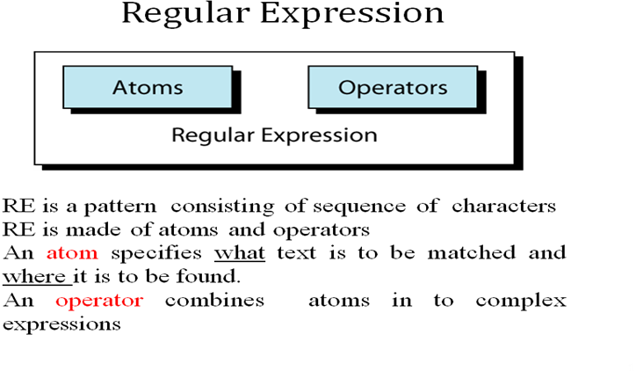
ATOM
An atom specifies what text is to be matched and where it is to be found.
An atom in a regular expression can be any one of the five types
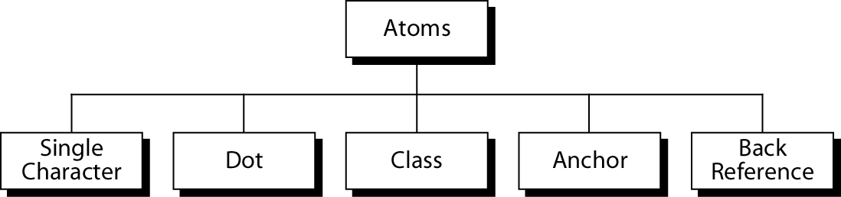
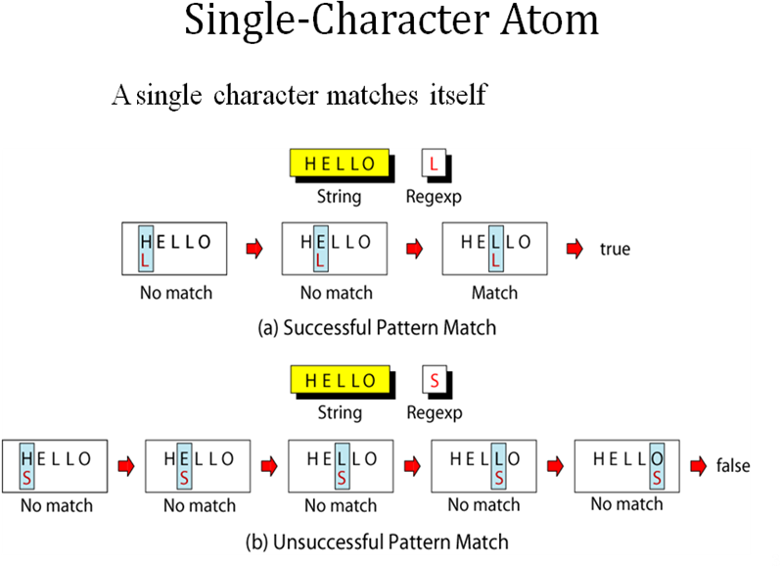
Class Atom
matches only single character that can be any of the characters defined in a set:
Example: [ABC] matches either A, B, or C.
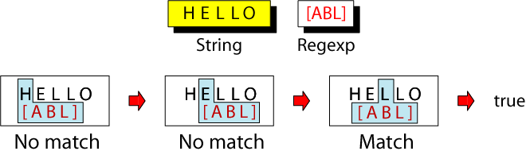

Notes:A range of characters is indicated by a dash, e.g. [A-Q]
Can specify characters to be excluded from the set
e.g. [^0-9] matches any character other than a number

Anchors
Anchors tell where the next character in the pattern must
be located in the text data.
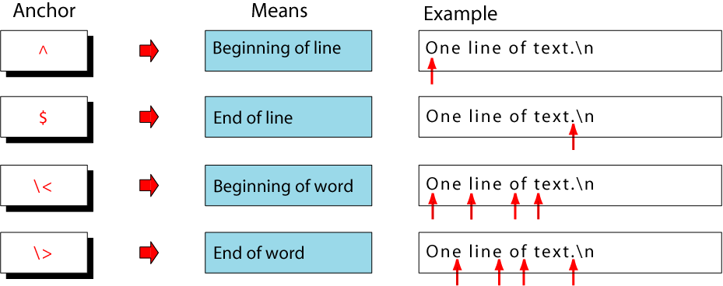

Back References: \n
- used to retrieve saved text in one of nine buffers
- can refer to the text in a saved buffer by using a back reference:
ex.: \1 \2 \3 ...\9
Operators
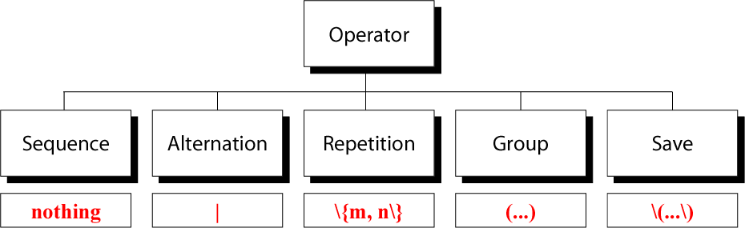
Sequence Operator
In a sequence operator, if a series of atoms are shown in a regular expression, there is no operator between them
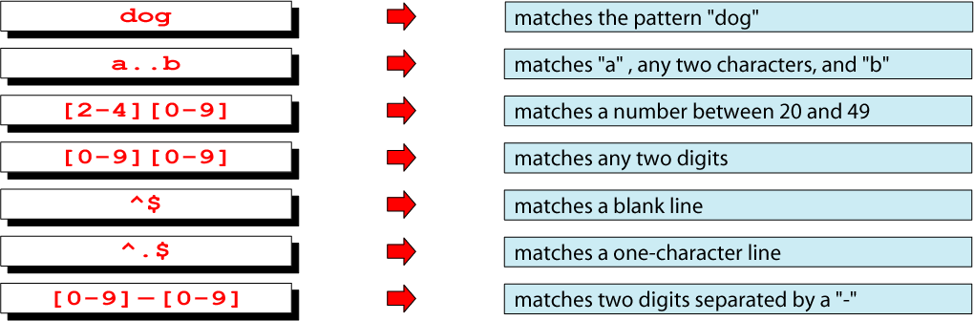
Alternation Operator: | or \|
operator (| or \| ) is used to define one or more alternatives

Repetition Operator: \{…\}
The repetition operator specifies that the atom or expression immediately before the repetition may be repeated.
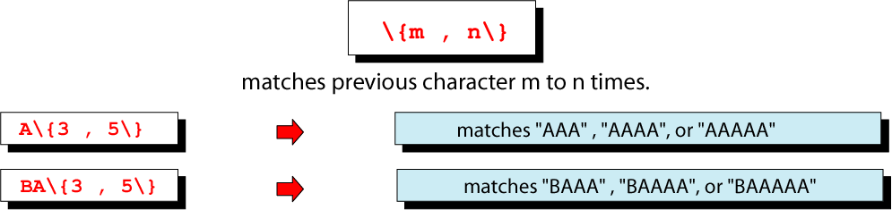
Basic Repetition Forms
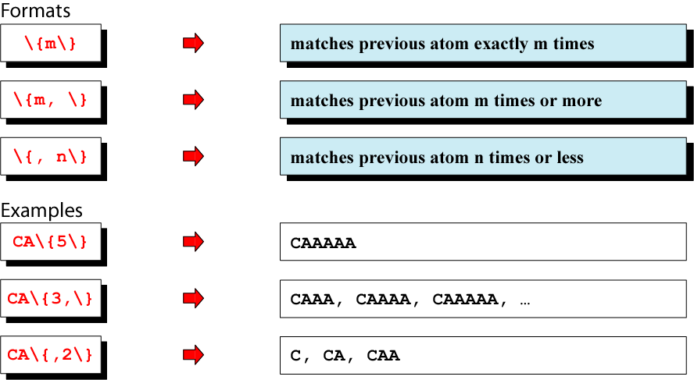
Short Form Repetition Operators
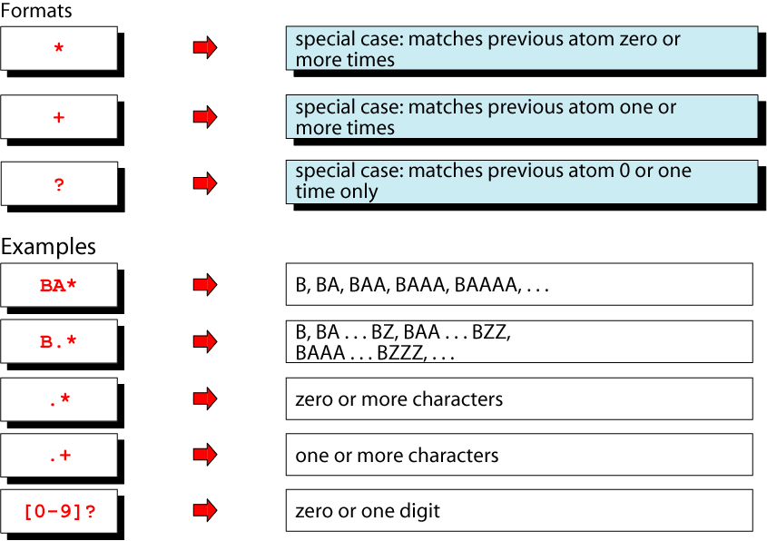
Group Operator
In the group operator, when a group of characters is enclosed in parentheses, the next operator applies to the whole group, not only the previous characters.
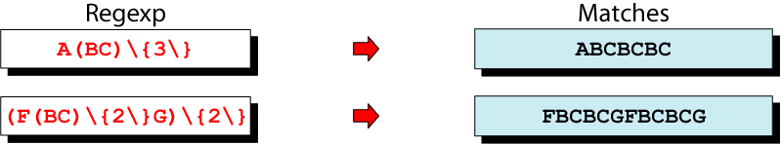
Save operator
- text string to one of the nine buffers for later referenceset of escaped paranthesis, \(……\),copies a matched
Qn 15(a). Explain sed command with examples. Compare it with other editors
- sed scans the input file, line by line, and applies a list of instructions(sed script) to each line in the input file.
- the script ,which is usually a separate file, can be included in the sed command line if it is a one line command
- it does not change anything in the original file
sed script format
- instructions included in command line
sed -e ‘address command’ input _file
- instructions placed in a file
sed –f script.sed input _file
create script file using text editor
save file with .sed extension
address command
- each instruction consists of address and command
- address select the line to be processed by the command
- ! is optional .select the non matching line
- command indicates the action that sed is to apply to each input line that matches the address
sed operation
- each line in the input file is given a line number by sed
- this number is matched against the address
- copies an input line to the pattern space
- applies all the instructions in the script, one by one, to all pattern space lines that match the specified address in the instruction
- copies the content of the pattern space to the output file unless directed not to by the -n option flag
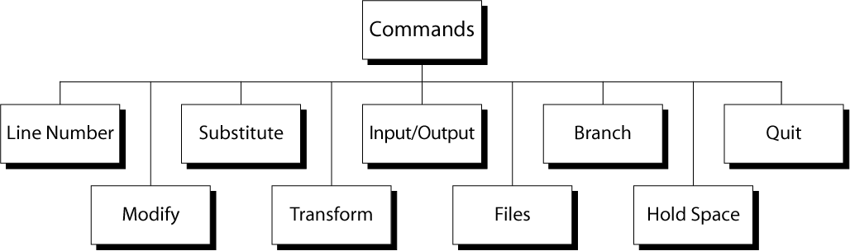

Line number command (=)
- put line number at the beginning of the line
- line number is written on a separate line
Eg
sed “=” file1
sed “/^o/=“ file1
modify commands
- commands are used to insert, append, change ,or delete one or more whole lines
- The modify command require that any text associated with modify command be placed on the next line in the script
- therefore the script must be in a file
- all modify command apply to the whole line
- cannot modify just a part of a line
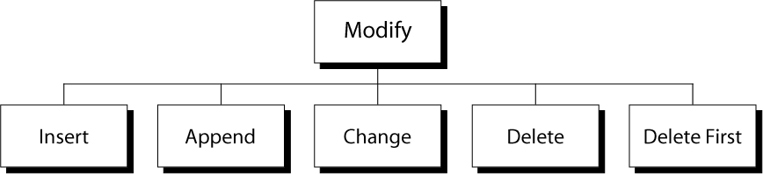

substitute command (s)
- replaces text that is selected by regular expression with a replacement string
- similar to find and replace
- address s/ pattern/replacement string/flag(s)
- replaces text that is selected by regular expression with a replacement string
- similar to find and replace
- address s/ pattern/replacement string/flag(s)
transform command
- transform one set of characters to another set
- each character in the first string represents a value to be changed to its corresponding characters in the second string
- sed ‘y/aeiou/AEIOU’ input_file
I/O Commands
- sed automatically reads text from the input file and writes data to standard output
- I/O commands allows the user to control the input and output
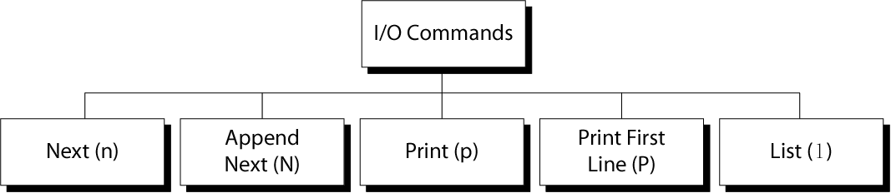

File Commands
- allows to read and write from/to file while processing standard input
- read:
- address r filename
- write:
- address w filename
Branch Commands
- Change the regular flow of the commands in the script file
- allow to skip one or more commands in the script file
- Branch label
  - Each branch command must have a target, either a label or the last instruction in the script
  - If “label” is supplied, execution resumes at the line following :label; otherwise, control passes to the end of the script
Quit (q) Command
Syntax: [addr]q
  - Quit (exit sed) when addr is encountered.
Example: Display the first 50 lines and quit
% sed -e ’50q’ datafile

(b) Compare grep and awk.
- grep ‘ reg exp” file1
- awk ‘$0 ~ /reg exp/ print ( $0)’ file1
- grep -v ‘ reg exp” file1
awk ‘$0 !~ /reg exp/ print ( $0)’ file1

Qn 16. Explain the use of grep command, with suitable examples
global regular expression print(GREP)
- used to search the input file for all lines that match a specified regular expression and write them to the standard output
grep operation
- for each line in the standard input file, grep performs the following operations
- copies next input to the pattern space. pattern space is a buffer that can hold one line of text
- applies the regular expression on that line
- if there is a match, the line is copied from the pattern space to the output
- grep utilities perform these three operations on each line in the input
grep is a search utility.
It can search only for the existence of a line that matches a regular expression
If a line matches with regular expression, it is send to the output
If the line does not match the RE , it is not printed
The line selection is based on the RE
grep is a filter
grep cannot be used to add, delete or change a line
grep cannot be used to print only a part of a line
grep cannot read only a part of a file
grep cannot select a line based on the contents of previous or next line

grep family options
-b precedes each line by the file block number in which the match is found
-c prints only a count of number of lines matching the pattern
-i ignores uppercase or lowercase
-l prints list of files that contain at least one line matching the pattern
-n shows the line number of each line before the line
-v inverse output. print lines that do not match the pattern
-x print only lines that entirely match pattern

-f file list of string that are to be matched are in file
grep family expressions

atoms | grep | fgrep | egrep
character
dot
class
anchors |  |  | ^ $
back reference

operators | grep | fgrep | egrep
sequence
repetition
alternation
group
save

search for file content
specific directory
- To find a list of all files in current directory that contain a pattern
- the l options prints out the filename of any file that has at least one line that matches the grep expression
- grep –l ‘pattern’ *
search all directories in a path
- if you don’t know where the file is located, use the find command with execute criterion
- find ~ -type f –exec grep –l “pattern” {} \;
Qn 17. Write a shell script to print a number in reverse order
#!/bin/bash
echo“Enter a number”
readnum
rev=0
while [ $num –gt 0 ]
do
num=`expr $num% 10`
rev=`expr $rev * 10`
rev=`expr $rev + $rem`
num=`expr $num/ 10`
done
echo “Reverse is”
echo $rev

Save program as rev.sh
Compile it as $sh rev.sh
Qn 18(a).Write a shell script to check whether an input number is even or odd
evenodd.sh
a=$1
if [ `expr $a%2` –eq 0]
then
echo “$a is even”
else
echo “$a is odd”
fi

sh evenodd.sh 87
(b) Explain parameter passing in shell scripts.
Arguments are passed from the command line into a shell program using the
positional parameters $1 through to $9. Each parameter corresponds to the
position of the argument on the command line.
The first argument is read by the shell into the parameter $1, The second
argument into $2, and so on. After $9, the arguments must be enclosed in
brackets, for example, ${10}, ${11}, ${12}.Some shells doesn't support this
method. In that case, to refer to parameters with numbers greater than 9, use
the shift command; this shifts the parameter list to the left. $1 is lost,while
$2 becomes $1, $3 becomes $2, and so on. The inaccessible tenth parameter
becomes $9 and can then be referred to.

#!/bin/bash
# Call this script with at least 3 parameters, for example
# sh scriptname 1 2 3
echo "first parameter is $1"
echo "Second parameter is $2"
echo "Third parameter is $3"
There is one more way to assign
values to the positional parameters, using the set command.
$ set Helping hands are holier than praying lips
The above command sets the value $1 with “Helping” , $2 with “hands” and so on.
To verify, use echo statement to display their values.
$ echo $1 $2 $3 $4 $5 $6 $7
Helping hands are holier than praying lips
You can simply use $* or $@
$ echo $*
Helping hands are holier than praying lips
$ echo $@

Qn19. Explain the architecture of X Window system
- The X Window System was specifically designed to allow the graphical output of a program running on one machine to appear on a different machine
- A machine running an X windowing system can launch a program on a remote computer
- All the CPU processing happens on the remote computer but the display of the application appears on the local machine
- In 1984, the Massachusetts Institute of Technology released the X Windows System.
- When MIT started working on the project, they were aware that people were working with several types of graphic displays.
- Every display had its own methods for drawing lines and shapes on the screen
- If an application were to write to all these displays, then there had to be several versions of the application – one for each type of display
- MIT decided that the display should be handled by a separate program
- The application would instead send its output to this display-handling program.
- This led to a very important splitting of the application into client and server components.
- In a typical Windows application, the job of handling the PC’s display is handled by the client application itself
- X reverses this paradigm and its architecture places the responsibility of handling the display on the server
- The application itself runs as a client.
- The X server and clients may be on the same machine, but X shines when they are separated and was primarily designed to run over a TCP/IP network.
The transmission is totally reliable; X uses the TCP protocol

Qn 20)a. Explain various signals in UNIX.
Sending signals to process
- Signals are software interrupts that are sent to program when an event happens
- The events themselves might be request from users or indications that a system problem has occurred
Sending Signals Using the Keyboard
- There are certain key presses that are interpreted by the system as requests to send signals to the process with which we are interacting:
- Ctrl-C Pressing this key causes the system to send an INT signal (SIGINT) to the running process
- Ctrl-Z Pressing this key causes the system to send a TSTP signal (SIGTSTP) to the running process
Sending Signals from the Command Line
- Another way of sending signals to processes is done using various commands, usually internal to the shell:
- The kill command accepts two parameters:
- a signal name (or number),
- And a process ID.
Kill -<signal><PID>
- Kill -9 9876
Sending Signals Using System Calls
- A third way of sending signals to processes is by using the kill system call.
- This is the normal way of sending a signal from one process to another
- System Call: intkill (pid_tpid, intsigCode)
- kill () sends the signal with value sigCode to the process with PID pid

Qn 20)b. List the network management tools in UNIX.
Network management tools
- When you work in a distributed environment then you need to communicate with remote users and you also need to accessremote machines..
- There are several Unix utilities which are especially useful for users computing in a networked distributed environment.
The ping utility
- The ping command send an echo request to a host available on the network. Using this command we can check if our remote host is responding well or not
- ping command checks whether the connection with a remote host is working
- The ping command is useful for
- Tracking and isolating hardware and software problems
- Determining the status of the network and various foreign hosts
- Testing, measuring and managing networks.
- In a ping command, we use a remote host’s name or IP address as argument.
ping 192.168.0.150
Sample output is given below:
- PING 192.168.0.150 (192.168.0.150) 56(84) bytes of data.
- 64 bytes from 192.168.0.150: icmp_req=1 ttl=128 time=4.00 ms
- 64 bytes from 192.168.0.150: icmp_req=2 ttl=128 time=0.258 ms
- 64 bytes from 192.168.0.150: icmp_req=3 ttl=128 time=0.257 ms
ftp utility
- ftp stands for file transfer protocol
- This help you to transfer files from one computer to another
ftp hostname or ip address
- Above command prompt you for login and password
- Once you are authenticated, you are able to transfer files
telnet utility
- Many times you would be in need to connect to a remote unix machine and work on that machine remotely
- Telnet is a utility that allows a user at a machine to make connection to another machine
- Once you are login using telnet, you can perform operations on your remotely connected machine
Eg: telnet> open 192.168.0.8
Trying to 192.168.0.8…
Connected to 192.168.0.8

